Federal Aviation Administration (FAA)

**Flight Standards Service (AFS)**

**Pilot Records Database (PRD)**

**WEB API INTERFACE CONTROL DOCUMENT (ICD)**

Version 1.0

(Draft)



**Author: Leidos**

**Created: March 31, 2022**

**DEPARTMENT OF TRANSPORTATION**

**FEDERAL AVIATION ADMINISTRATION**

OFFICE OF FINANCE AND MANAGEMENT

**Office of Information & Technology Services (AIT)**

**Revision History Summary**

|  |  |  |
| --- | --- | --- |
| **Release No.** | **Date** | **Revision Description** |
| 1.0 | 3/31/2022 | Draft |

|  |
| --- |
| **Pilot Records Database (PRD)  Web API Interface Control Document (ICD)   Authorization Memorandum** |

**FAA INFORMATION TECHNOLOGY (AIT) PROJECT MANAGEMENT CERTIFICATION**

We have carefully assessed this Interface Control Document (ICD) for the Pilot Records Database (PRD) project. The completion of this document is in accordance with the requirements of the Federal Aviation Administration’s (FAA) System Development Life Cycle (SDLC) Methodology

By signing below, we, the Project/Program Manager and the Project Sponsor, acknowledge having reviewed this document and hereby approve the contents.

Chas Lin ________________________ _____________________

PRD AIT SIGNATURE DATE

Project Manager

Christopher Morris ________________________ _____________________

PRD Business SIGNATURE DATE

Program Manager

Karen Lucke _______________________ _____________________

PRD SIGNATURE DATE

Project Sponsor

**INTERFACE CONTROL DOCUMENT (ICD)**

**TABLE OF CONTENTS**

**Page #**

1.0 Scope 1

1.1 System Identification 1

1.2 Points of Contact 2

1.2.1 Interface Coordination 3

1.3 PRD External System Interface Requirements 3

1.4 Program/Project References 3

2.0 Concept of Operations 4

2.1 Systems Overview 4

2.1.1 Carrier Data Feed 4

2.2 Functional Allocation 4

2.2.1 Carrier Data Feed (TBD) 4

2.3 Transactions 6

2.3.1 Carrier Data Feed 7

2.4 Security and Integrity 7

3.0 Detailed Interface Requirements 8

3.1 Air Carrier Data Feed 8

Appendix A: Acronyms & Abbreviations 9

**LIST OF TABLES**

**Page #**

Table 1: PRD Points of Contact 2

Table 2: Interface Coordination List 3

Table 3: Acronyms and Abbreviation 9

**LIST OF FIGURES**

**Page #**

Figure 1: Air Carrier External Bulk Submission API Okta OAuth 2.0 5

# Scope

This Interface Control Document (ICD) specifies the interface requirements to be met by the Pilot Records Database (PRD) and the external participating Air Carrier systems. This ICD describes the concept of operations for the interface, defines the message structure and protocols that govern the interchange of data, and identifies the communication paths along which the data are expected to flow.

## System Identification

President Obama signed Public Law 111-216, Section 203, of the “United States Code 44703(i)” on August 1, 2010. This Act significantly changed several areas of Title 49, United States Code of Federal Regulations (CFR). Section 203 of the Act requires the creation of a database that would provide immediate electronic access for airlines to a prospective pilot’s qualifications, training, certification and enforcement history for a hiring decision. For purposes of the PRD application, “pilot” is defined as an airman who has the duty position of pilot in command or second in command.

The FAA maintains the database for hiring purposes only. The FAA has issued regulations and final requirements to protect and secure the personal privacy of any individual. The PRD includes FAA, Air Carriers as well as other employers of pilots records identified below.

This effort will encompass the full System Development Life Cycle (SDLC) for defining and implementing the FAA Pilot Records Database. This includes the integration of several data sources so that a single interface can access and provide the present and historical certification, qualification and historical pilot records to Carriers in accordance with the provisions of Public Law 111-216, Section 203. The deliverables for this effort are: (1) FAA Pilot Records Database, and (2) all standards necessary to define the data input and consumption from the multiple stakeholders, and (3) all supporting documentation required by the FAA Office of Quality, Integration & Executive Services (AQS-200) System Development Life Cycle (SDLC), 02/14/2013, Rev 7.

FAA Records

The following FAA information is collected:

1. Records that are maintained by the Administrator concerning current pilot certificates, including pilot medical certificates and associated type ratings and information on any limitations to those certificates and ratings.
2. Records maintained by the Administrator concerning any failed attempt of an individual to pass a practical test required to obtain a certificate or type rating under part 61 of title 14, Code of Federal Regulations since August 1, 2010.
3. Summaries of legal enforcement actions resulting in a finding by the Administrator of a violation of title 14 CFR or a regulation prescribed or order issued under title 14 CFR that was not subsequently overturned since August 1, 2010.
4. Summaries of incidents and accidents limited to on or after October 1, 2015.
5. Drug or alcohol records limited to on or after August 1, 2005.

Air Carrier and Other Records

From any Air Carrier or other person (except a branch of the Armed Forces, the National Guard, or a reserve component of the Armed Forces) that has employed an individual as a pilot of a civil or public aircraft, or from the Trustee in bankruptcy for the Air Carrier or person.

1. Records pertaining to the individual that are maintained by the Air Carrier (other than records relating to flight time, duty time, or rest time) or person, including records under regulations set forth in:

* Section 91.1051 of title 14, Code of Federal Regulations;
* Section 121.683 of such title;
* The Act requires records maintained pursuant to §§ 121.111(a) and 121.219(a) to be included in the database[1];
* Section 125.401 of such title; and
* Section 135.63(a)(4) of such title.

1. Other records pertaining to the individual's performance as a pilot that are maintained by the Air Carrier or person concerning:

* Training, qualifications, proficiency, or professional competence of the individual, including comments and evaluations made by a check airman designated in accordance with section 121.411, 125.295 or 135.337 of such title;
* Disciplinary action taken with respect to the individual that was not subsequently overturned;
* Release from employment or resignation, termination, or disqualification with respect to employment; and
* Drug or alcohol records limited to on or after August 1, 2005.

## Points of Contact

The table below lists the points of contact for the PRD project.

Table : PRD Points of Contact

| **Contact Role** | **Name** | **Organization** | **E-mail** | **Phone Number** |
| --- | --- | --- | --- | --- |
| **FAA Contacts** | | | | |
| PRD AIT Project Manager | Chas Lin | AEM-110 | Chas.Lin@faa.gov | 202-267-6692 |
| PRD Business Program Manager | Christopher Morris | AFS-620 | Christopher.Morris@faa.gov | 405-954-4646 |

### Interface Coordination

The PRD project team will coordinate with the following contacts to implement PRD releases. Updates to this list will be made as new interfaces are identified.

Table : Interface Coordination List

| **Contact Role** | **Name** | **Organization** | **E-mail** | **Phone Number** |
| --- | --- | --- | --- | --- |
| **PRD FAA Contacts** | | | | |
| PRD AIT Project Manager | Chas Lin | AEM-110 | Chas.Lin@faa.gov | 202-267-6692 |
| PRD Business Program Manager | Christopher Morris | AFS-620 | Christopher.Morris@faa.gov | 405-954-4646 |
| PRD Business Sponsor | Karen Lucke | AFS-620 | Karen.Lucke@faa.gov | 312-520-3195 |

## PRD External System Interface Requirements

This section identifies the requirements for Air Carrier data.

Program/Project References

The following documents were referenced in the preparation of this ICD:

* PRD Functional Requirements Document V2.6, 7/30/2021 (Includes Use Cases and Requirements Traceability Matrix [RTM]).
* AC 120-68J - Pilot Records Database and Pilot Records Improvement Act Document Information - [AC 120-68J](https://www.faa.gov/documentLibrary/media/Advisory_Circular/AC_120-68J.pdf)

# Concept of Operations

This section describes the PRD external Air Carrier interface system

## Systems Overview

This section provides an overview of the PRD interfacing system.

### Carrier Data Feed

A system interface will be developed to allow Air Carriers to transmit data via Web API. This interface will be external to the FAA.

## Functional Allocation

This section describes the functional allocation for the PRD interfacing system (Air Carrier Systems).

### Carrier Data Feed (Web API)

The PRD will interact with the Carrier Data Feed to allow Carriers to transmit data Web API. The process will be triggered from the PRD Air Carrier Database when the Air Carrier accesses the system to submit pilot data.

The proof-of-concept approach to carrier data submission is the use of a web interface based on an Extensible Markup Language (XML) upload. This would be supported by an internal Simple Object Access Protocol (SOAP) for a Windows Communication Foundation (WCF) web service that integrates with the user interface (UI). The XML submission is validated and processed by the web service.

Since the proof of concept, a new application programming interface (API) has become an industry standard known as Representational State Transfer (REST). REST has six characteristics:

1. Client-server. REST is separated from the UI and provides portability across multiple platforms and improved scalability.
2. Stateless. The request from the client to the server contains all the information necessary to understand the request so the session state is kept entirely on the client.
3. Cacheable. By caching the response, the client cache may reuse the response data for later, equivalent requests.
4. Uniform interface. REST interfaces are general which simplifies the system architecture and the visibility of the interactions.
5. Layered system. The layered system supports hierarchical layers and constrains the component behavior so each component cannot “see” beyond the immediate layer of which they are interacting.
6. Code on demand. REST allows client function to be extended with the use of applets or scripts which reduces the number of features required to be pre-implemented.

It is recommended to use new REST architecture that provides loosely-coupled interoperability and additionally supports Air Carrier agencies that need to directly integrate and process submissions without a UI. The new architecture will be based on a REST-based web API that supports a JSON data format and comes with a robust security model and near real-time processing, this architecture will give the PRD more agility to develop, evolve, as well as replace other legacy services.

Reliable and resilient services are a high priority for the PRD architecture. Air Carriers will use the APIs on a daily basis to submit data. The Stage IV first phase implementation allows users to login to the Air Carrier External Portal and enter data manually. The proof-of-concept XML submission was relying on a SOAP-based WCF service end point that is open only for the UI. External partners or applications are unable to submit files directly.

The new Web API implementation will expose an HTTPS-based RESTful Web API to the participating air carriers to integrate directly without having to login and upload. The advantages of using REST over SOAP are:

1. Easy-to-understand standard
2. Smaller learning curve
3. Efficient (uses a smaller message format such as JSON)
4. Fast (no extensive processing needed)
5. Closer to other web technologies in design

The data exchange will be JSON-based and will be validated by a JSON schema on the API Server. The figure below depicts the data flow through the API architecture. The REST clients can vary in type, such as web applications, batch jobs, or services, and can be developed in any language. Once the preliminary schema validation is successful, the API server will parse the JSON data and process business rule validations and then save the data to the backend.

Figure 1: Air Carrier External Bulk Submission API Okta OAuth 2.0

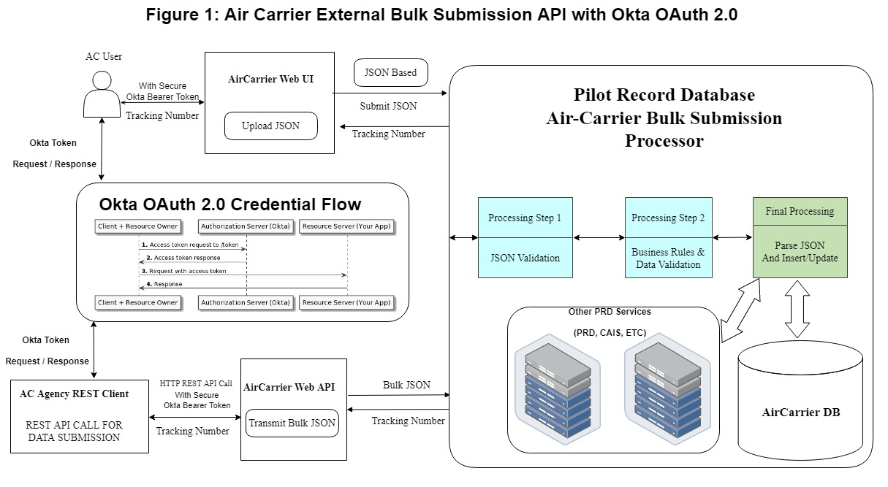

#### Security and Authorization: OAuth 2.0

The API architecture will be developed using security best practices with the input of FAA Information Security to validate and verify the architecture. All the communication and data delivery will be encrypted end-to-end through HTTPS.

OAuth is an open standard for access and permits Internet users to grant websites or application access without providing them with passwords. OAuth 2.0 is the most popular wayto Secure API Services and will be adopted for the Bulk Submission API.

* The client will pass its API credentials (private key and client ID) to the PRD Web API Authorization Component. The PRD API returns an access token that has an expiration time, usually one minute.
* The client packages the token into all future Web API functional calls.
* The architecture also enables a refresh token method to renew the token automatically for each call.

#### POSTMAN Automated Testing Tool

Postman is a scalable API testing tool that quickly integrates into a continuous integration and continuous delivery/deployment (CI/CD) pipeline. Automated build and test steps are triggered by CI to ensure reliable code changes are merged into the repository. The code is delivered quickly and seamlessly as part of the CD process. Postman has evolved from a simple API testing tool to a collaboration platform for API development. Postman's features simplify each step of building an API and streamline collaboration so users can create better APIs faster.

#### Web API Management

Logs and monitoring will be in place to ensure that requests to a system can be traced back to the consumer of the data. All APIs logs will be stored in a separate log database. With a centralized logging system, email alerts can be set up to notify the API development team if an error or issue occurs.

As technology moves more towards the Microsoft Cloud computing service (Azure), for APIs that are externally consumed by carriers and agencies, API management can be handled by Microsoft’s out-of-the-box Azure API Management. The advantage of using Azure API Management is that Azure keeps all APIs behind a single static IP or domain, and protects the APIs with keys, tokens, and IP filtering.

The API management will provide logging, analytics, authentication, security policies, throttling, multi­environment (production, development, staging) support, and API documentation. With the new API architecture, getting access to data and managing the security behind access will be streamlined.

The API architecture will provide loosely-coupled interoperability for a variety of data consumers. The new data interoperability model will provide consistent data models, documentation, improved security and near real time integration. All these benefits are provided by the RESTful architecture based on proven standards, protocols, and design patterns.

#### Carrier Data Feed

Air Carrier data feed will be Web API.

## Transactions

The PRD database does not store data per se; rather, data resides in the “golden source” and is requested upon demand. The architecture is based on the Model-View-Controller (MVC) Façade Pattern implementing a single point-of-entry framework which isolates functions. Service Oriented Architecture (SOA) is also incorporated, which uses proxy classes to represent the services and standard SOA interaction patterns.

The hosting layer resides on the Internet Information Server (IIS). The interface resides between the service layer and the consumer and is built around the messaging model containing Data Transfer Objects (DTOs). The DTO is a container for a set of aggregated data to be transferred. The objects do not have behavior but rather only the properties for storage and retrieval of data. Using this design pattern will facilitate the desire to perform cloud technology.

### Carrier Data Feed

A system interface will be developed to allow Air Carriers to transmit data via Web API.

## Security and Integrity

Security requirements for each interfacing system are specified inside the Detailed Interface Requirements/Security Requirements.

# Detailed Interface Requirements

This section specifies the requirements for the interfaces between systems.

Air Carrier Data Feed

**The Air Carrier will provide the data that is listed in the AC 120-68J - Pilot Records Database and Pilot Records Improvement Act -** [AC 120-68J](https://www.faa.gov/documentLibrary/media/Advisory_Circular/AC_120-68J.pdf)

<https://www.faa.gov/regulations_policies/advisory_circulars/index.cfm/go/document.information/documentID/1039941>

# Appendix A: Acronyms & Abbreviations

The table below lists the acronyms and abbreviations used throughout this document.

Table : Acronyms and Abbreviation

| **Acronym/Abbreviation** | **Acronym/Abbreviation Description** |
| --- | --- |
| AEM | Information & Technology Services – Enterprise Program Management |
| AFS | Flight Standards Service |
| AIT | Office of Information & Technology |
| AQS | Office of Quality, Integration & Executive Services |
| API | Application Programming Interface |
| CFR | Code of Federal Regulations |
| DTO | Data Transfer Object |
| FAA | Federal Aviation Administration |
| HTTPS | Hyper Text Transfer Protocol Secure |
| ICD | Interface Control Document |
| IIS | Internet Information Server |
| JSON | JavaScript Object Notation |
| MVC | Model-View-Controller |
| NDR | National Driver Register |
| OAUTH | Open Authorization |
| PAR | PRD Airman Record |
| PRD | Pilot Records Database |
| REST | Representational State Transfer. |
| RTM | Requirements Traceability Matrix |
| SDLC | Software Development Life Cycle |
| SFTP | Secure File Transfer Protocol |
| SOA | Service Oriented Architecture |
| SOAP | Simple Object Access Protocol |
| UI | User Interface |
| WCF | Windows Communication Foundation |
| XML | Extensible Markup Language |

1. The references to these particular provisions in part 121 appear to be the result of a simple typographical error as those sections of the regulations, which were in effect when Public Law 111-216 was enacted, do not relate to record keeping.